Operations/HR –Brainwave Matrix Solutions

TASK-2 Topic:Designing an Employee Supports Program: Goals and Strategies

In our Employment Success Program overviews, we’ve discussed why employee supports are a critical component of an effective social enterprise. Building an effective employee supports program for your social enterprise is an essential component of delivering the supports and services that help workers secure, succeed, and advance in employment and get on the pathway to self-sufficiency.

Designing an employee supports program is a multi-phase process. In this deep dive, we will cover the first two steps of the process:

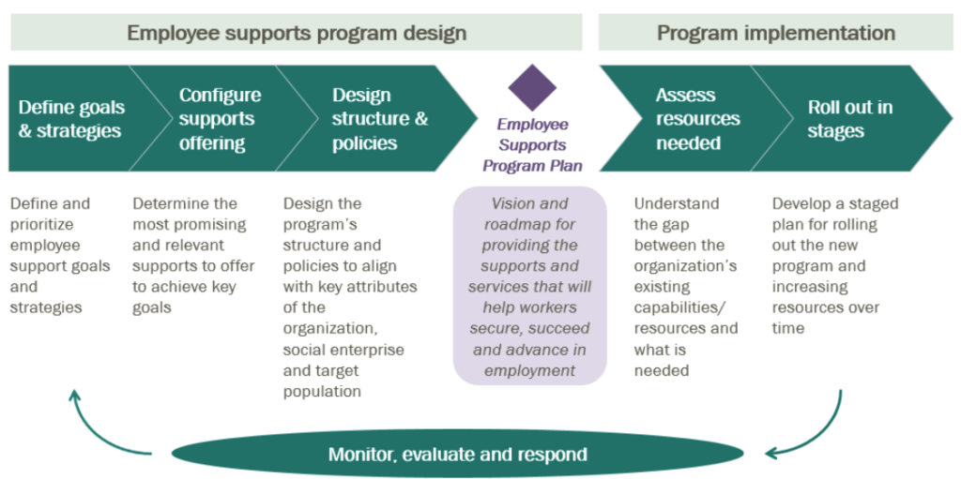

The first step is defining the goals and strategies that your employee supports program is trying to achieve. The second is configuring which employee supports you will offer, determining the most promising and relevant ones in order to achieve key goals. In subsequent learning guides we will cover the further stages of employee support program design.

**1. Define Goals and Strategies**

There is no single model for employee supports. Your social enterprise’s programming should be designed to achieve certain key goals unique to your social enterprise, taking into consideration all of the idiosyncratic factors affecting your organization and target population. The first step in doing so, is defining your social enterprise’s goals.

**Define Goals**

The first step of designing an employee supports program for your social enterprise is to define the overarching goals for your program. In doing this, you will want to think holistically about your social mission and your target population, building on an understanding of the goals and needs of your employees. Learning the common challenges that affect your employees is, unsurprisingly, done best by talking directly to current and former employees of your social enterprise. Consider conducting interviews, focus groups, and/or surveys, as they can be a useful way to conduct this research.

Some important questions to consider are:

* What barriers do they have?
* What skills should be developed or enhanced?
* What outcomes do you want to see them achieve during or after social enterprise employment?
* What will motivate employees to be successful?

By building an understanding of your employees’ needs, you can begin to craft overarching goals for your social enterprise and identify what your social enterprise can do to support these goals. It is also worth considering what your social enterprise can’t do. Realistically, your employee supports programming can’t do everything, so stick to clear and attainable goals.

For example, a social enterprise might identify four key goals for it’s programming:

1. Demonstrate employability in the social enterprise
2. Build towards a better future
3. Transition to external employment
4. Succeed in the labor market

Once you have developed the overarching goals for your social enterprise, it is helpful to align them along the workforce development continuum. This will help provide the necessary context in order to develop appropriate strategies to meet these goals.

Aligning your goals along the workforce development continuum clearly shows which are more relevant to employees earlier on in, or even before, the social enterprise experience. Others may be more relevant to those later on in, or after, the social enterprise employment. You can now begin to identify specific strategies to meet the goals you identified.

**Define Strategies**

Second, articulate what strategies and beliefs underlie your goals. This helps begin to articulate how you will achieve success.

While there is no single model for employee supports and each social enterprise is different, there are some common themes that emerge among many social enterprises. REDF has identified six key strategies for employee supports programming that apply to many social enterprises’ goals:

1. Get and keep benefits and Earnings : Ensuring that your employees are reaping the benefits of work.
2. Lend the playing field: Removing your employees barriers so they are not at a disadvantage compared to other applicants for jobs outside the social enterprise.
3. Connect to employment : Helping your employees succeed in the workplace outside of social enterprise employment.
4. Prevent Back Tracking: Ensuring that the gain made during social enterprise employment are permanent.
5. Incentivize Success: Providing incentives for success, beyond a paycheck.
6. Build towards a better Future:Providing opportunities for your employees to achieve long term stability.

Next, identify the strategies to support each of the goals. Continuing our example from earlier, the social enterprise would identify the following strategies as supporting the relevant goals:

| **Goals** | **Strategies** |
| --- | --- |
| Demonstrate employability in the social enterprise | Help employees get and keep benefits and earnings |
| Transition to external employment | Level the playing field |
| Connect with employers |
| Succeed in the labor market | Prevent backtracking |
| Incentivize success |
| Build toward a better future | Develop transferable skills |
| Promote and facilitate savings |

Finally, identify the strategies that support each of the goals. Continuing our example from earlier, the social enterprise would identify the following strategies as supporting the relevant goals:

| **Goals** | **Strategies** |
| --- | --- |
| Demonstrate employability in the social enterprise | Help employees get and keep benefits and earnings |
| Transition to external employment | Level the playing field |
| Connect with employers |
| Succeed in the labor market | Prevent backtracking |
| Incentivize success |
| Build toward a better future | Develop transferable skills |
| Promote and facilitate savings |

**Defining Employee Grievances**

Employee grievance can be defined as the discontentment caused by the gap between what your employees expect and what they fail to get. It may or may not be justified but needs to be tackled very carefully. A considerable amount of time must be invested by the HR person to talk to the employees to understand their grievances.

Identifying employees’ grievances can be a challenge in personnel management. However, specific ways can help you in this job. You can consider the following points to know that the

1.Changed Behaviour:Human Behaviour reflects a lot about how they are feeling. Every good HR manager should have the considerable emotional intelligence to handle grievance. A routine direct observation can be great problem solver. Periodic one an one conservations, group meetings, collective bargaining, and occasions when direct observation can be the highest effective.

2.Suggestion Boxes: For anonymous complaints, it can be placed in different accessible locations within the office. The fear of adverse managerial actions can be avoided through this method.

3.Open-Door Policy: It is one of the best [**employee empowerment**](https://www.vantagecircle.com/en/blog/employee-empowerment/) techniques in the workplace. [**Open door policy**](https://blog.vantagecircle.com/open-door-policy/) refers to [**open communication and transparency**](https://www.vantagecircle.com/en/blog/transparency-in-the-workplace/) that allows them to be in touch with the senior management to get their grievances addressed.

4.Opininons Survey: We can use these surveys in understanding different employee opinions regarding [**workplace satisfaction**](https://www.vantagecircle.com/en/blog/employee-satisfaction/). It may be conducted periodically in the form of questionnaires and self-report measures.

5.Effective Exit- Interview:

If answered honestly, [**exit interviews**](https://www.vantagecircle.com/en/blog/exit-interview/) can provide constructive reflections on the impact that the [**company culture**](https://www.vantagecircle.com/en/blog/company-culture/) has on its employees. By knowing the reasons for leaving the job, employers can make the best possible changes with improved management policies.

Here's a piece of advice from us. Make sure you have a well-thought-out list of [**exit interview questions**](https://www.vantagecircle.com/en/blog/exit-interview-questions/) on hand. It will undoubtedly aid in gathering accurate feedback from your current employees.

**Here’s a list of leading causes of Employee Grievances:**

1. Undesirable working conditions in physical terms.
2. Changes without prior notice.
3. Poor employee relations.
4. Improper wage adjustments.
5. Dissatisfactory office policies in case of:

* Promotion
* Demotion
* Transfer
* Discharge
* Leaves
* Overtime

1. Violation of laws.
2. Inadequate safety,health, and welfare amenities.
3. Labor-management hostility.
4. Incidences of workplace favoritism and nepotism.
5. Lack of organizational discipline.

No matter what sort of organization it is, in everyday working environments, problems occur pretty frequently, which demands reasonable solutions. Every complaint needs careful and proper handling. Your primary aim should be in dealing with grievances informally. However, if the criticism is severe, the employee might raise a follow a formal grievance.

By law, every company should have a grievance policy. The formal, written document should let the employees know the point of contact if they have an issue and set forth the process and the time limits of each action. Here’s how you can take action on employee grievances that you should consider for a timely resolution.

**8 Effective Steps To Handle Employee Grievances Most Effectively:**

**1. Create the system:**

The first thing is to set up the grievance redressal system for your companies to help your employees lodge complaints and grievances so that you can resolve them. Something that you must consider here is-

The grievance procedure must be added to the employee handbook’s content so that all can easily access it.

Someone must take responsibility for grievance receipts. You must ensure the employees that their complaints are placed in confidence. Generally, it should be someone from the Human Resources Department.

The place of receiving the complaints must be within reach to all. That is, it should be located centrally. If you use a grievance box, it should be in the area of common accessibility.

As it might involve personal matters, it is essential to focus on confidentiality while dealing with employees’ grievances. Involving the least number of people prevents the issue from being widespread.

The complaints put forwards must be followed up timely. That is, no issue should be on hold for a long time. It should follow a schedule to expect a certain level of responsiveness within a specified period.

**2. Acknowledge the grievance:**

It would help if you listened more than you talk while dealing with employee grievances. When your employees come to you lamenting over an issue, lend them your ear.

That doesn’t mean that you should resolve it immediately but so that your employees know that their complaint is acknowledged. Let your employees know that you have received their report and are willing to do something about it.

**3. Investigate:**

Not all issues qualify for a hearing. Generally, it is essential to review whether the grievance is valid or not. Inquire about the incidents or situations and gather any relevant information. It may not always be necessary but if the matter involves other staff, they will need to be informed and given a chance to explain themselves and put forward their own shreds of evidence.

Once the investigation is over, you can arrange a formal meeting.

**4. Hold the formal meeting:**

The employee with the grievance and all the relevant parties should be called to be present in the formal hearing. The employee can put forward any evidence that backs up the complaint and explain how they would like the problem to be resolved. Later on, you can circulate the minutes of the meeting notes.

**5. Take your decision and act accordingly:**

This is the decision making phase. Once you have collected all the required information and closely examined the situation, you should decide.

You might decide to accept the grievance in whole or part or reject it altogether. It would help if you let the employee know in writing about the actions that you will take. At the same time, you can advise the employee on how they should deal with similar situations.

**6. Appeal process:**

Your employee might not accept your decision and has the [**right to an appeal**](https://www.hr-24.co.uk/articles/when-can-employees-appeal/). Here again, your grievance policy should outline the terms and conditions of the appeal process.

It should start with an appeal letter written by the employees, informing them why they want the decision to be reconsidered. To ensure impartiality, the appeal should be heard by another manager or supervisor who was not a part of the first meeting.

An appeal hearing with new evidence should follow this. The decision of the same should be informed to the employee in writing. If your employee is still not satisfied, it can either be mediated or escalated to the employment tribunal.

**7. Review the situation:**

It’s always healthy to have an objective look back at your decisions. If the [**employee is happy**](https://www.vantagecircle.com/en/blog/employee-happiness-workplace/) with the resolution, you were good at settling the issue. In fact, it can prove significant to your company culture.  
If the prevailing policy ensures justice, it can foster a sense of pride and accountability in the employees’ work. That’s the benefit of implementing a fast and effective grievance procedure.

**8. Uproot the main cause of grievance:**

Your aim is to go for a long-lasting solution. That is, a formal complaint should be addressed once and for all. This prevents your employees from coming back again and again with the same issue.

The key solution here lies in identifying the root cause of the problem and making sure to solve the problem completely, with the scope of adjustments, if necessary.

**Conclusion**

The successful operation of a grievance procedure requires the maintenance of sufficient records, experience, and fair treatment to all.

However, some exceptional circumstances might arise when the process mentioned above needs to be modified for the better. The Human Resource Department reserves the right to revise the same as necessary and appropriate.